CHURCH GROWTH PRELIMINARY ENQUIRY

PLANNING DOCUMENT

The intention of this form is to provide an overview of all questions included in the Church Growth Preliminary Enquiry online process. Please plan your submission using this document, and then submit your enquiry using the online form.

The Church Growth Preliminary Enquiry is a brief overview of your project and request. If we wish to progress the proposal, you will be invited to complete the more comprehensive Church Growth Grant Submission form. We trust that this 2 stage process will minimise any unnecessary effort by the enquirer.

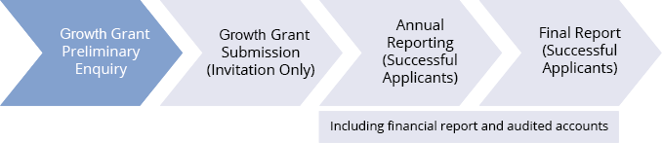

Instructions to complete this form:
- Read the criteria and FAQs on the Gospel Future Fund website
- Note the next lodgement period on our website
- Please work within 100 word maximum for each question, unless noted otherwise.
- Complete the online form. There are no attachments for the Church Growth Preliminary Enquiry form.

MINISTRY DETAILS
Date | Title of your project
Name of proposed applicant |  |  | Annual budget of the applicant
Contact person |  |  | Position
Phone |  | Mobile | Email
Start date |  | End date | Proposed funding period
Prospective income sources to support the project (pending and confirmed)

Provide a brief description of the proposed applicant, including its mission/vision and experience.

CHURCH GROWTH GRANT QUALIFICATIONS
Does the potential grantee have tax deductible (DGR Item 1) status? | YES/NO
Is the potential grantee a Tax Concessional Charity (TCC)? | YES/NO
You must answer at least one question above “yes”; otherwise we cannot help you.
Is the total request less than A$60,000? | YES/NO
Is the end of your Financial year between 1 January and 30 June? | YES/NO
Please check our Preliminary Enquiry lodgement period is consistent with the above.

YOUR PROJECT SUBMISSION OVERVIEW
Provide a summary of the project
How will the project aid the spread of the Gospel?
Summarise the Project’s anticipated outcomes. (Detailed KPIs will be requested in the Grant Submission form)
Provide an overview of the project budget, including income sources and expenses and excluding the Gospel Future Fund request over 3 years (a detailed budget will be required if successful for the Grant Submission stage).

Year ended: | 30/06/__ | 30/06/__ | 30/06/__
Income
Expenditure
Need/Surplus

What amount are you requesting from Gospel Future Fund (for each project year)?

Year ended: | 30/06/__ $______ | 30/06/__ $_______ | 30/06/__ $_______

ADDITIONAL QUESTIONS
How will the project continue to be funded after the completion date of the grant?
How did you learn about Gospel Future Fund?

