CHURCH PLANT GRANT PRELIMINARY ENQUIRY

PLANNING DOCUMENT

The intention of this form is to provide an overview of all questions included in the Church Plant Grant Preliminary Enquiry online process. Please plan your submission using this document, and then submit your enquiry using the online form.

The Church Plant Grant Preliminary Enquiry is a brief overview of your project and request. If we wish to progress the proposal, you will be invited to complete the more comprehensive Church Plant Grant Submission form. We trust that this 2 stage process will minimise any unnecessary effort by the enquirer.

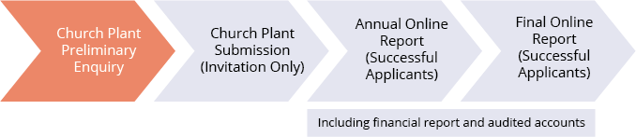

Instructions to complete this form:
- Read the criteria and FAQs on the Gospel Future Fund website
- Note the next lodgement period on our website
- Please work within 100 word maximum for each question, unless noted otherwise.
- Complete the online form.

MINISTRY DETAILS
Date | Name of your church (or proposed church)
Formal name of proposed applicant
Contact person |  |  | Position
Phone |  | Mobile | Email
Start date |  | End date | Proposed funding period
Prospective income sources to support the church plant project (pending and confirmed)

CHURCH PLANT GRANT QUALIFICATIONS
Is the proposed applicant an established legal entity? | YES/NO
Is the proposed applicant an income tax exempt charity (ITEC)? | YES/NO
If no to either, is it proposed to obtain an entity and ITEC? | YES/NO
Provide a brief description of your church plant, including its mission/vision | YES/NO

SUBMISSION OVERVIEW
Provide a summary of the church plant methodology (max100 words)
Summarise the proposed church plant project’s anticipated outcomes. (Detailed KPIs will be requested in the Submission form)
How will the church continue to be funded after the completion date of the grant?
How did you learn about Gospel Future Fund?
Provide an overview of the project budget, including income sources and expenses and excluding the Gospel Future Fund request over 3 years (a detailed budget will be required if the enquiry is to proceed)

Year ended: | 30/06/__ | 30/06/__ | 30/06/__
Income
Expenditure
Need/Surplus

What amount are you requesting from Gospel Future Fund (for each project year)?

Year ended: | 30/06/__ $______ | 30/06/__ $_______ | 30/06/__ $_______

ABOUT YOUR PROPOSED CHURCH PLANT

DETAILS OF THE LEADER
Name of leader:
Attach the church planter assessment for the leader
Will the leader be full-time? | YES/NO

DETAILS OF THE TARGET GROUP
Describe the target group
What evangelistic strategies have been developed?
Does the target group have the potential to fully fund the church in 3-5 years?

DETAILS OF THE LEADERSHIP TEAM
How many?
How long have they been meeting?
How regularly do they meet?
Do the socio demographics of the church plant team fit the strategy?
What prayer is being undertaken by the church plant team?

DETAILS OF SUPPORT
Is there a mother church(s) supporting the church plant? |  | YES/NO
If no mother church, is there a committed mentor? |  | YES/NO
Name of denomination or affiliation group |  | YES/NO
Committed funds from the church plant team? | $_______ pa in first year
Committed funds from the mother church? | $_______ pa in first year
Committed funds from other external sources? | $_______ pa in first year

DETAILS OF PLANNING
What is the structure and church governance model?
Is there a written plan/vision that has the commitment of the church planting team/governing body? | YES/NO

